Written Report- Kevin Molloy

1.Arc

Arcs can be seen all throughout my animation. In the screenshot below we can see 3 examples of this. The smaller character is sent into the air and lands in an arc, the bigger character swings his sword in an arc, and the smaller character’s dagger is sent flying away in an arc. Arc was pivotal when animating as a lot of my characters movements are through the air

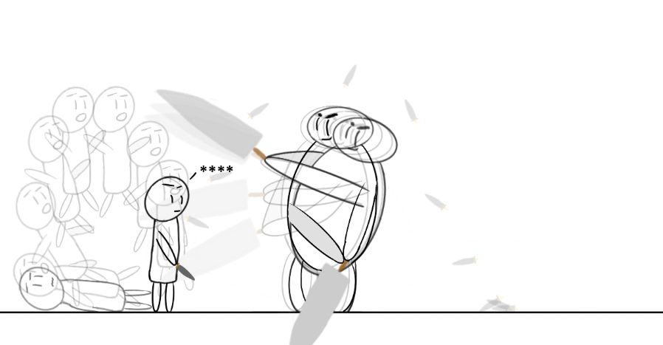  
In this image we see the smaller character jump into the air and land on the bigger character. His landing settles in an arc to show the difference in speed between the first two frames of the jump and the rest. The bigger character’s sword also falls out of his hands in this screenshot. The sword falls to the right and lands on the floor, with a slight arc as it settles to give an indication of the curved edge of the blade

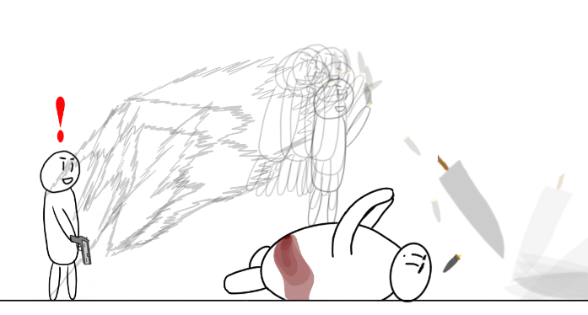

2.Anticipation

I used anticipation a lot during my animation, specifically when animating the bigger character. I felt that considering the size of my character, his movements should be slower and more telegraphed. This can be seen in the below image, where we see the bigger character winding up to slam his sword into the ground, as well as his legs rising into the air to again, telegraph the force of this attack

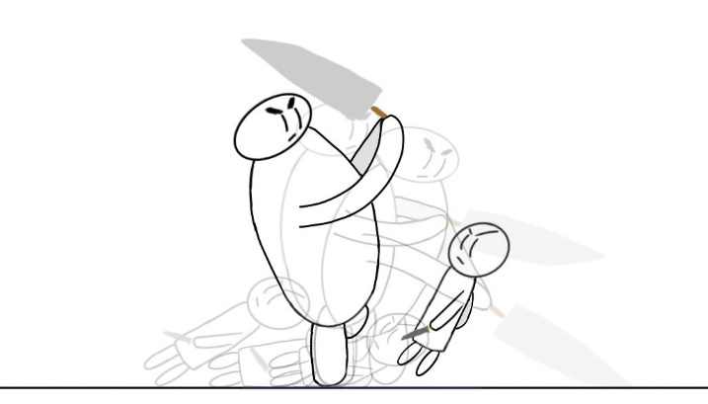

Then again in the image below. We see the bigger character telegraph another attack by looking over his shoulder with a smile, before swinging upward. The smaller character’s facial expression also changes from a confident and angry expression, to a bleak and fearful one, further telegraphing the events to follow

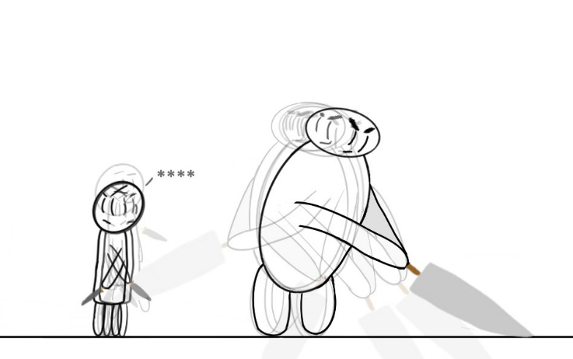

3.Slow in and Slow out

Slow in and Slow out was a key principal of this animation. Due to the amount of movement in my animation, I felt it vital to make proper use of this principal to make my characters move smoothly. In the screenshot below we see the bigger character swing at the smaller one. We see his movements start slow, are fast in the middle and slows again towards the end

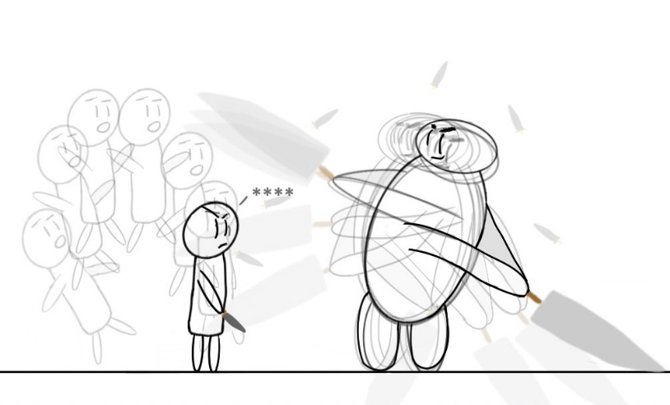

And again in this screenshot, we see the smaller character leap through the air. His initial dash through the air is fast and blurred, with only 2 frames. While the end of that movement is slower, with more frames. As the sword falls out of the big character’s hands, the space between frames is larger while its in the air, as opposed to the frames on the floor as it gently rocks to a halt

